**Ablation Study**

In this section, we will provide the effects of the reference branches, CA, SA, and loss function on model performance. We used the main branch without CA and SA as the baseline. We trained the network for 50 epochs with L2 loss and evaluated the PSNR and SSIM metrics in the format of mean ± SD (standard deviation) on the Kirby21 dataset (KKI01 to KKI05) with the scale factor of × 2. The detailed results of the ablation study are as follows.

1. **The effects of reference branch.** To study whether the model performance benefits from the upper and nether reference branches, we conducted ablation studies on the “Baseline”, “Upper branch”, “Nether branch” and “Upper & Nether branch”. As shown in Table 1, adding reference branches to the baseline is an effective way to improve SR performance. To be specific, after only adding the upper reference branch, the PSNR and SSIM metrics could be respectively improved from 41.70 dB to 42.94 dB and 0.9930 to 0.9955. Similarly, only adding the nether reference branch engorges the PSNR and SSIM to reach 42.92 dB and 0.9955, respectively. As shown in Table 1, using both upper and nether reference branches improve the PSNR and SSIM values at least 0.47 dB and 0.0006 over the model with only one reference branch. Fig. 5(a) depicts the convergence curves of different networks, and we can see that the network with the upper or nether reference branch converges faster than the baseline. It is worth noting that the network with three branches is better than using the independent upper or nether reference branch in terms of the PSNR value, SSIM metric, and convergence speed. The above comparisons demonstrate that assimilating the features from adjacent slices and the multi-branch architecture with reference branches is suitable for obtaining better results for brain MRI image SR.

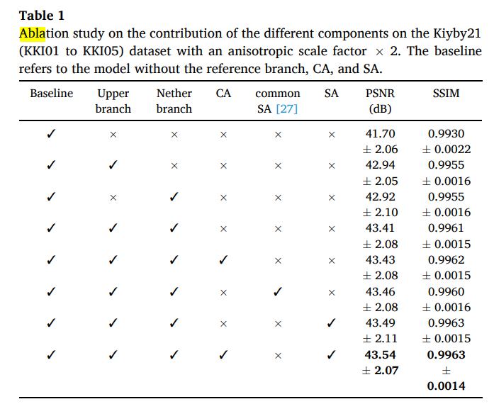

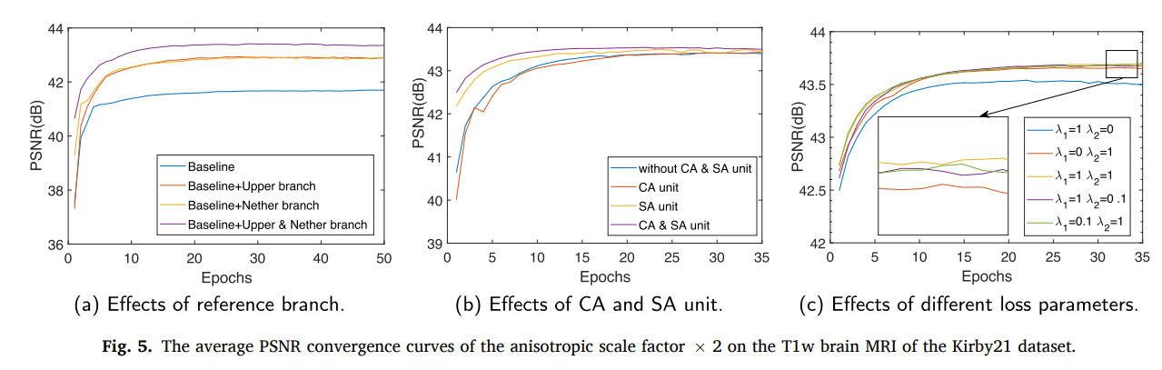

1. **Aaa**
2. **aa**
3. Aaa